- How long did you spend on the coding assignment? What would you add to your solution if you had more time? If you didn't spend much time on the coding test then use this as an opportunity to explain what you would add.

i have spend 2.5 hours for Api integration it took some time

- What was the most useful feature that was added to the latest version of your chosen language? Please include a snippet of code that shows how you've used it.

obviously redux store it is very useful to avoid api calls.
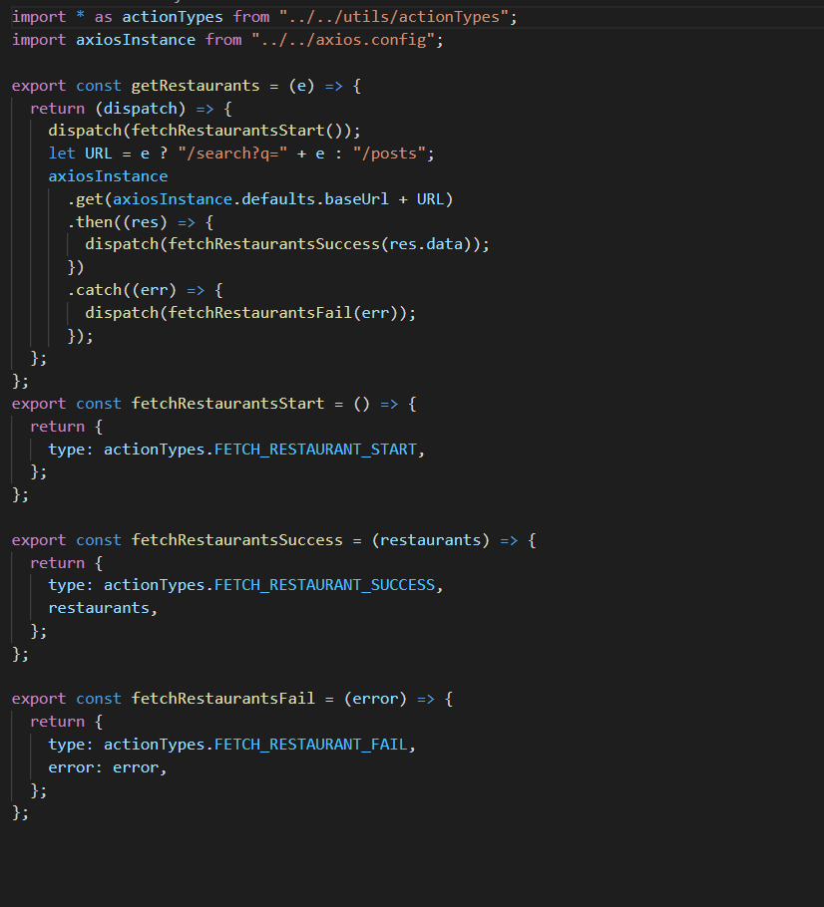

Used selector to query restaurants information from redux store . By doing this, in future, if response JSON schema changed, we can change only attributes in selector function

const getRestaurantList= state=> state.restaurantState.restaurants.restaurants||[];
const getRestaurentInfo =createSelector(getRestaurantList,items => items.map(item => {
return {
name:item.restaurant.name,
cuisines:item.restaurant.cuisines,
address:item.restaurant.location.address
}
}))

- How would you track down a performance issue in production? Have you ever had to do this?

No I didn’t get a chance to work in those area.

- How would you improve the API that you just used?.
My opinion is that we need to reuse api call if used more than one time needed in project.
Also there should be option to pass parameter and get the data filtered from backend to improve performance.

- Please describe yourself using JSON.
This is one best format to way to store information in an organized, easy-to-access manner and it can be accessed in any language while using restAPI.

json format
var jasonData = {
"age" : "24",
"hometown" : "Missoula, MT",
"gender" : "male"
};

